**Compétence :** Se repérer dans l’espace.

**Consigne :** Je place les clowns dans les mêmes cases.

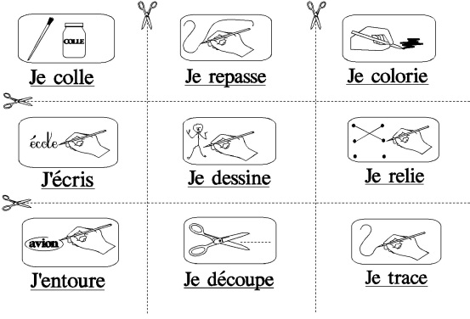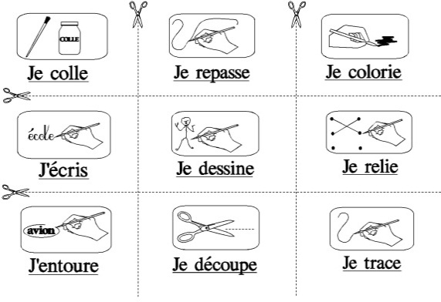

|  |  |  |  |  |  |  |
| --- | --- | --- | --- | --- | --- | --- |
|  |  |  |  |  |  |  |
|  |  |  |  |  |  |  |
|  |  |  |  |  |  |  |

|  |  |  |  |  |  |  |
| --- | --- | --- | --- | --- | --- | --- |
|  |  |  |  |  |  |  |
|  |  |  |  |  |  |  |
|  |  |  |  |  |  |  |

|  |  |  |  |  |  |  |
| --- | --- | --- | --- | --- | --- | --- |
|  |  |  |  |  |  |  |
|  |  |  |  |  |  |  |
|  |  |  |  |  |  |  |

|  |  |
| --- | --- |
| Prénom : | Date : |
|  |  |

|  |  |  |  |  |  |  |  |
| --- | --- | --- | --- | --- | --- | --- | --- |
|  |  |  |  |  |  |  |  |
|  |  |  |  |  |  |  |  |
|  |  |  |  |  |  |  |  |
|  |  |  |  |  |  |  |  |
|  |  |  |  |  |  |  |  |
|  |  |  |  |  |  |  |  |
|  |  |  |  |  |  |  |  |
|  |  |  |  |  |  |  |  |
|  |  |  |  |  |  |  |  |
|  |  |  |  |  |  |  |  |
|  |  |  |  |  |  |  |  |
|  |  |  |  |  |  |  |  |