**Commandes armes taiji quan**

**TAO DISTRIBUTION**

**1 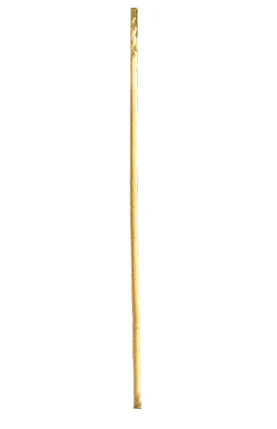 24,90€**

**2 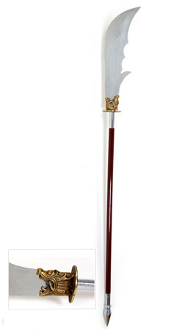 129,90€**

**3 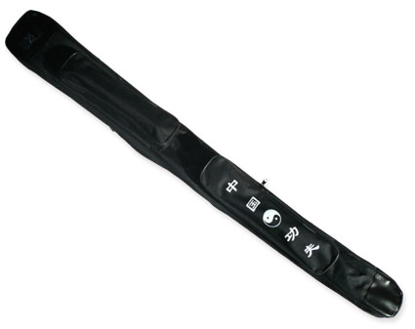21,90€**

**4**  **59,50€**

**5 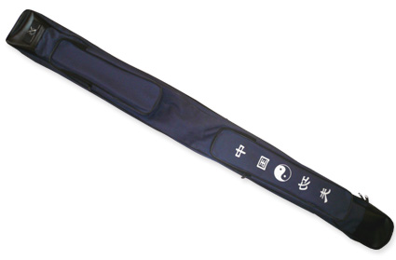 23,90€**

**6**  **14,00€** 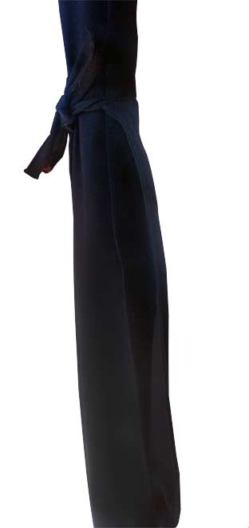

**7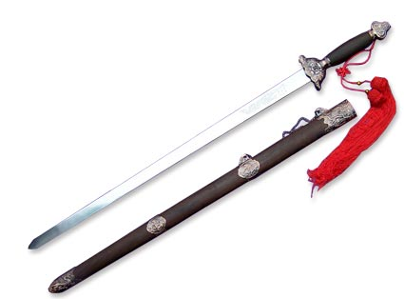 58,00€ 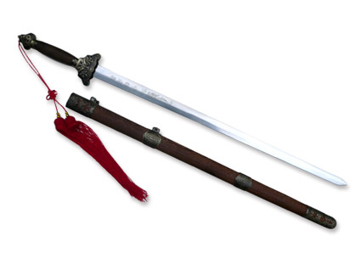8 9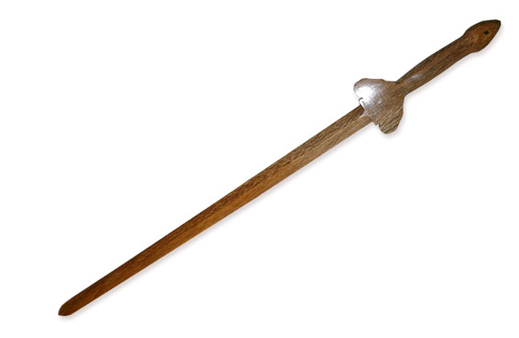20,99€ 10 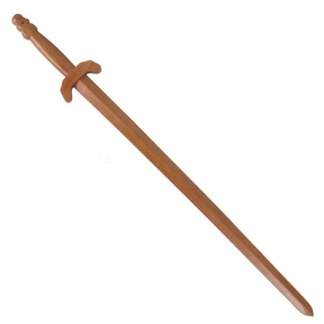 21,99€**

**11**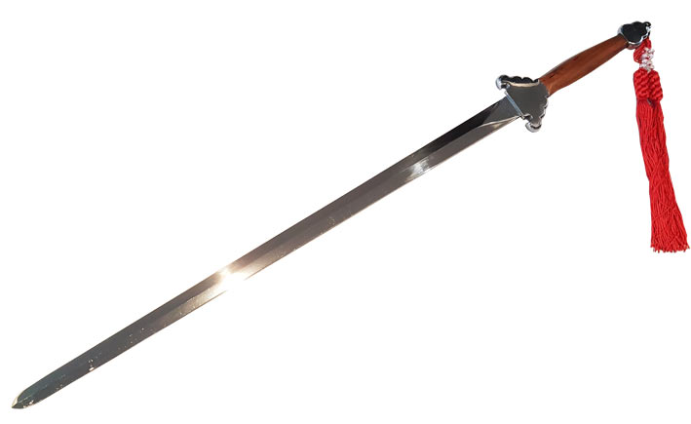 **48,00€**

**12 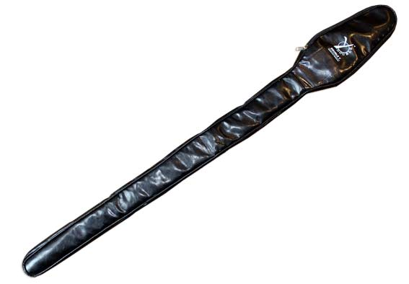 17,50€**

**13**  **13,50€**  **14 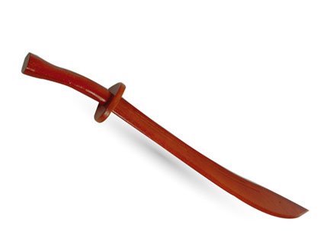 19,99€**

**15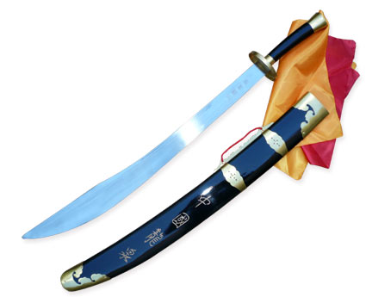 55,00€** 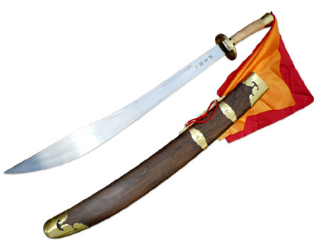

**16 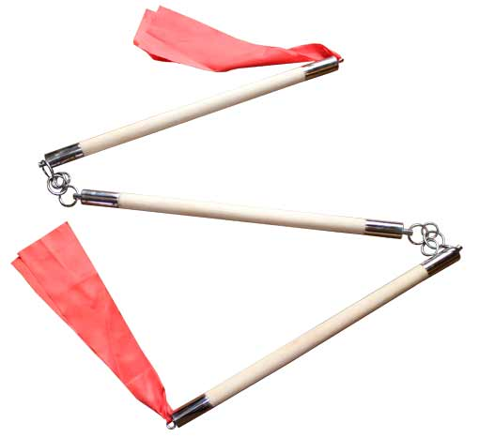 45,00€**

**17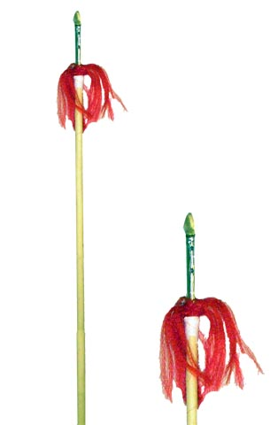 26,90€ 18  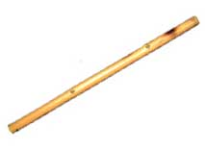8,50€**

**FUJI MAE**

**19 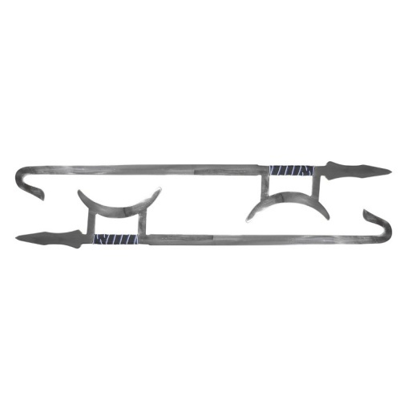 177,50€**

**20 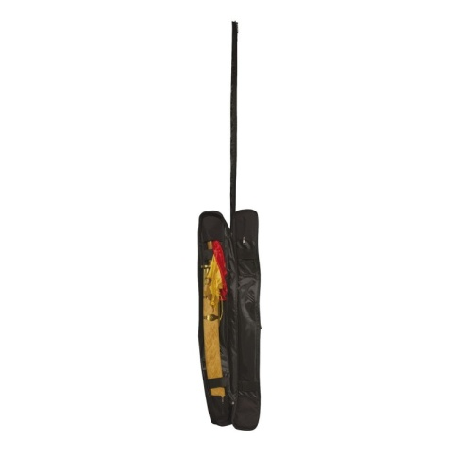 46,00 €**

**21 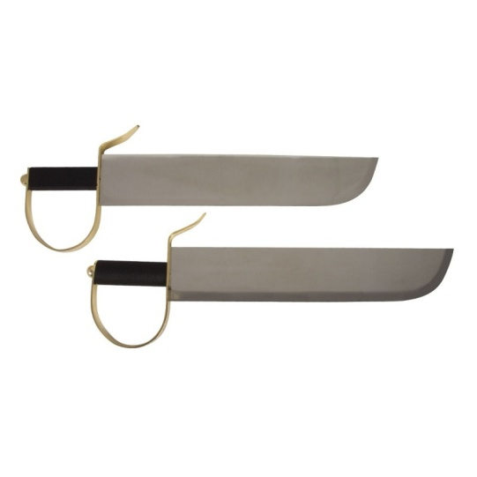 123,00€**

**22 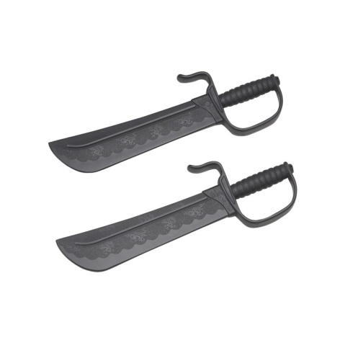 29,00€**

**23 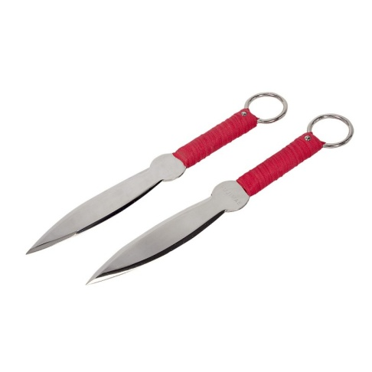 80,50€**

**24 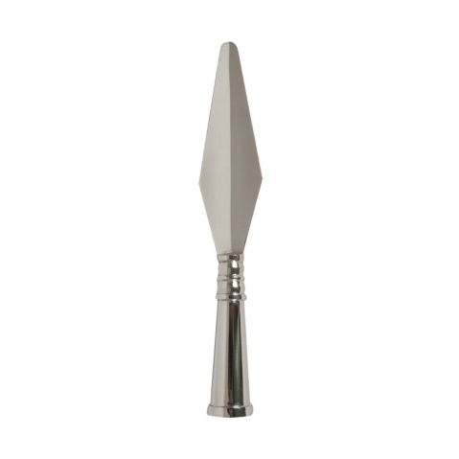 47,50€**

**25 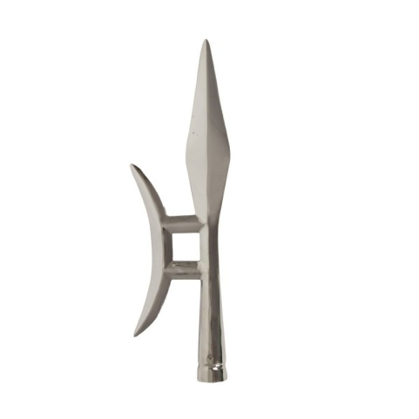 100 ,50€**

**26 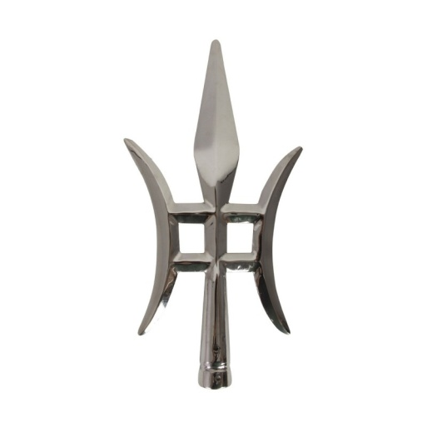 203,50€**

**27 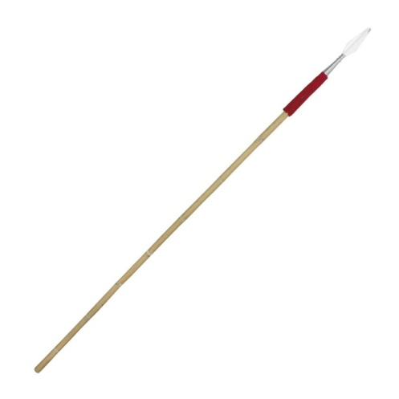 63,50€**

**28 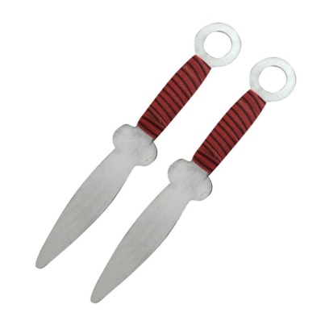 25,50€**

**29  29,00€ 30 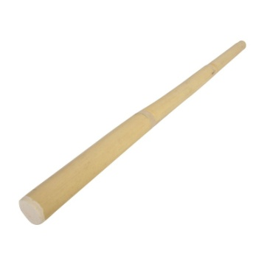6,00€**

**31  13,00€ 32 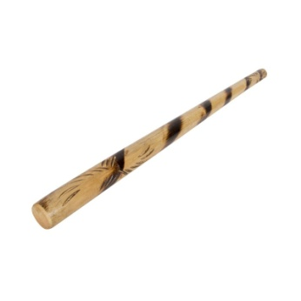16,50€**

**33 15,00€ 34 17,00€**

**35 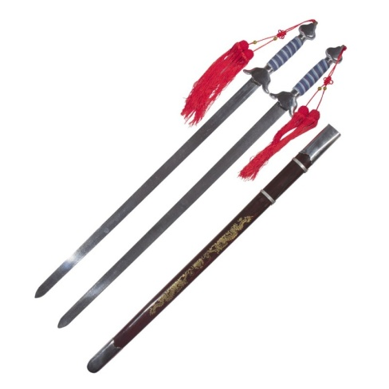 161,00 € 36** 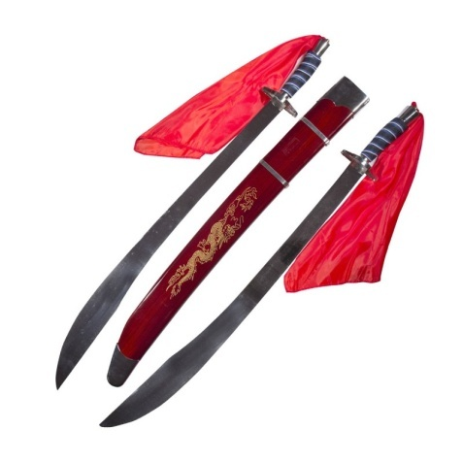

|  |  |  |  |  |
| --- | --- | --- | --- | --- |
| **NOM** | **PRENOM** | **COMMANDE N° ARTICLES** | **PRIX** | **TOTAL** |
|  |  |  |  |  |
|  |  |  |  |  |
|  |  |  |  |  |
|  |  |  |  |  |
|  |  |  |  |  |
|  |  |  |  |  |
|  |  |  |  |  |
|  |  |  |  |  |
|  |  |  |  |  |
|  |  |  |  |  |
|  |  |  |  |  |
|  |  |  |  |  |